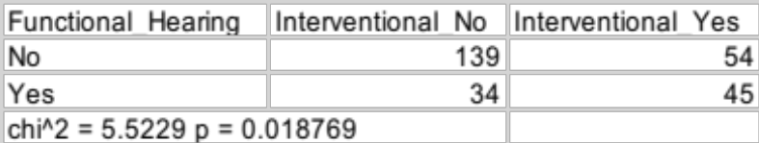

Supplementary Table 2. Numbers of cases in which functional hearing was achieved by the criteria recommended by Adunka and colleagues (post-operative hearing 80 dB or better at 500 Hz) tabulated against the study design (interventional or not).

